SHEEN WAKES WEEK 2019
WAKES CHURCH SERVICE
SUNDAY 20th OCTOBER at 11am
WAKES SUNDAY LUNCH
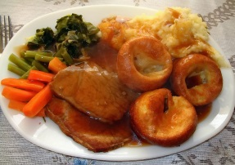
SUNDAY 20th OCTOBER
12.15 in Sheen Village Hall
Roast Dinner- £9.00
To Book Contact Ann 84396
Before 14th October to avoid disappointment

WAKES WHIST DRIVE
FRIDAY 18thOCTOBER
7.30pm in Sheen Village Hall
All profit goes to St Luke’s Church

WAKES COFFEE MORNING
SATURDAY 26th OCTOBER
10.30am to Noon
in Sheen Village Hall
ADMISSION 50P including Coffee/Tea and Biscuits
FUN, GAMES AND BACON BUTTIES

