AFTERNOON TEA
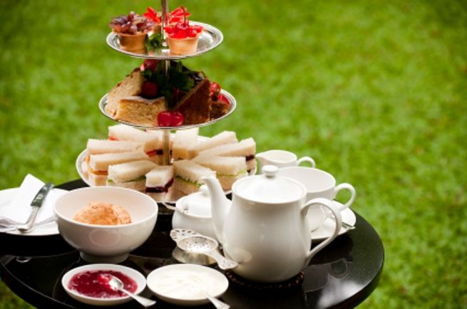
SERVED in
SHEEN VILLAGE HALL
SUNDAY 7TH JULY
3 til 5
In aid of
st luke’s flower festival
selection of sandwiches
cakes, scones and fresh cream
as much tea and coffee as you can drink
All for £8
to book a place please contact
pam on 01298 84809

