SHEEN WAKES WEEK 2018
WAKES CHURCH SERVICE
SUNDAY 21st OCTOBER at 11am
WAKES SUNDAY LUNCH
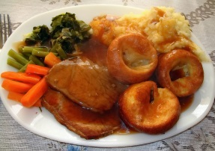
SUNDAY 21st OCTOBER
12.15 in Sheen Village Hall
Roast Dinner- £9.00
To Book Contact Ann 84396
Before 15th October to avoid disappointment

WAKES WHIST DRIVE
FRIDAY 19th OCTOBER
7.30pm in Sheen Village Hall
All profit goes to St Luke’s Church

WAKES COFFEE MORNING
SATURDAY 27th OCTOBER
10.30am to Noon
in Sheen Village Hall
ADMISSION 50P including Coffee/Tea and Biscuits
FUN, GAMES AND BACON BUTTIES

